**What Differentiates the Church of Christ?**

Q. What are some of the distinctive teachings that differentiate the church of Christ from other Christian churches?

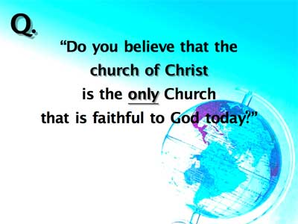



1)

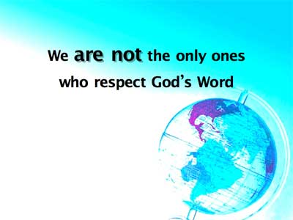

It is true that many do not believe the Bible is inspired. They reject the Creation story and the miracles. Some religionists are surprised when pressure is exerted to learn that their own preachers deny the inspiration of the Bible.

[2 Pet. 1:20](https://biblia.com/bible/nasb95/2%20Pet.%201.20),[21](https://biblia.com/bible/nasb95/2%20Pet%201.21) –   
“but know this first of all, that no prophecy of Scripture is a matter of one’s own interpretation, for no prophecy was ever made by an act of human will, but men moved by the Holy Spirit spoke from God.”

[I Thess. 2:13](https://biblia.com/bible/nasb95/1%20Thess.%202.13) –   
“and for this reason we also constantly thank God that when you received from us the Word of God’s message you accepted it not as the word of men, but for what it really is, the word of God, which also performs its work in you who believe.”

We make no apology for believing that the inspired writers gave us what God intended them to write. We know that the apostles believed that the words they were writing came from God. This is one of the basic beliefs of the church of Christ.

However. . .there are other groups who do believe the Bible, so we are not “the only ones.” Evolution and humanism are being opposed by conservative preachers in some denominations. Some are trying to oust the modernists from their theological schools and are leading fights in the creation/evolution battles, so this point alone is not what makes us different.

2)

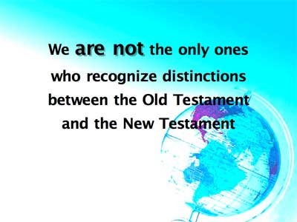

What is that distinction?

A. [Jeremiah 31:31-34](https://biblia.com/bible/nasb95/Jer%2031.31-34) (READ) – God promised a new covenant. The New Testament reveals that it has come, [John 1:17](https://biblia.com/bible/nasb95/John%201.17) – “For the Law was given through Moses; grace and truth were realized through Jesus Christ.”

B. [Hebrews 8:7-13](https://biblia.com/bible/nasb95/Heb%208.7-13); [9:15-17](https://biblia.com/bible/nasb95/Hebrews%209.15-17) (READ) [Heb. 8:7ff](https://biblia.com/bible/nasb95/Heb.%208.7ff) direct quote from [Jer. 31:31ff](https://biblia.com/bible/nasb95/Jer.%2031.31ff)

C. [Romans 15:4](https://biblia.com/bible/nasb95/Rom%2015.4) – “for whatever was written in earlier times was written for our instruction, that through perseverance and the encouragement of the Scriptures we might have hope.”

D. We must still study the O.T. and learn from its examples but we look to Christ in the New Testament for Salvation.

E. [Hebrews 1:1 -2](https://biblia.com/bible/nasb95/Heb%201.1%20-2) “God, after He spoke long ago to the fathers in the prophets in many portions and in many ways, 2\* in these last days has spoken to us in His Son, whom He appointed heir of all things, through whom also He made the world.”

F. [Acts 4:12](https://biblia.com/bible/nasb95/Acts%204.12) –   
“and there is salvation in no one else; for there is no other name under heaven that has been given among men, by which we must be saved.”

We are not “the only ones” who understand this, however. Look at the percentage of other religious groups who meet on the first day of the week rather than the Sabbath day for worship and who reject animal sacrifices, polygamy, incense, Passover, etc. There are some others who apparently have believed [Col. 2:14](https://biblia.com/bible/nasb95/Col.%202.14) which says,

[Col. 2:14](https://biblia.com/bible/nasb95/Col.%202.14)  
“Having canceled out the certificate of debt consisting of degrees against us and which was hostile to us; And he has taken it out of the way, having nailed it to the cross.”

3)

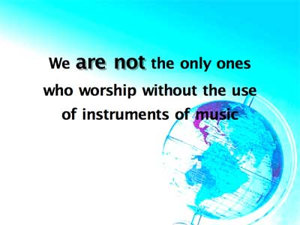

True, this does make us different. But there is a basic reason for it, every passage in the New Testament referring to church music identifies it as “a capella” which is a Latin term (Latin has one “p”), or the Italian term (which has two “p’s” a cappella), both mean “as in church, ” or “in the style of the chapel.”

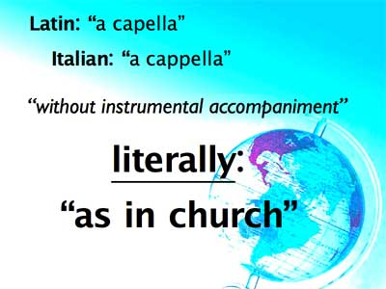

In all the Bible there are only nine verses that speak about church music.

[Matt. 26:30](https://biblia.com/bible/nasb95/Matt.%2026.30) – After the institution of the Lords Supper, the disciples sang a hymn.  
[Mark 14:26](https://biblia.com/bible/nasb95/Mark%2014.26) – Parallel to [Mt. 26:30](https://biblia.com/bible/nasb95/Matt.%2026.30)  
[Acts 16:25](https://biblia.com/bible/nasb95/Acts%2016.25) – Paul and Silas in prison were singing  
[Romans 15:9](https://biblia.com/bible/nasb95/Rom%2015.9) – Mentions singing  
[I Cor. 14:15](https://biblia.com/bible/nasb95/1%20Cor.%2014.15) – The early church was to sing with the Spirit  
[Eph. 5:19](https://biblia.com/bible/nasb95/Eph.%205.19) – “singing and making melody with your heart to the Lord.”  
[Col. 3:16](https://biblia.com/bible/nasb95/Col.%203.16) – “teaching and admonishing one another with psalms and hymns and spiritual songs, singing with thankfulness in your hearts to God.”  
[Heb. 2:12](https://biblia.com/bible/nasb95/Heb.%202.12) – Mentions singing in the midst of the congregation.  
[James 5:13](https://biblia.com/bible/nasb95/James%205.13) – “Is anyone cheerful? Let him sing praises.”

The reason we do not use instruments of music in our worship is, they were not used by the apostles, there were not used by the New Testament church, they were not used by the church for several hundred years after the church was established.

To make such an addition is to presume what God desires, and man has no right to presume what God desires, he must obey what he has revealed.

The fact that instruments were available, but were left out of the New Testament worship holds a significance often overlooked. Old Testament sacrifices and worship involved outward ceremony that became routine. It ceased to be from the heart. A child of God was such by birth, not conviction. He had to be taught who God was. Their worship opportunities became chores and duties that they did not put themselves into ([Malachi 1:7-14](https://biblia.com/bible/nasb95/Mal%201.7-14)). Worship became a burden to them.

As a Christian, one learns of God and loves him before becoming his child (see again [Jeremiah 31:31ff](https://biblia.com/bible/nasb95/Jer%2031.31ff)), his worship is to be from the heart, his life is a sacrifice, and instead of some mechanical substitute, the Christian, by singing, gives of himself in worship.

However. . .we are not the only ones who reject the instrument. Throughout history there have been groups that have realized the importance of worship according to the New Testament design, rather than according to the traditions of men.

4)

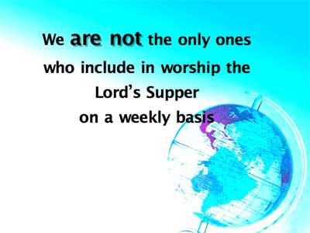

WHY DO WE DO THIS?

Jesus instituted the Lord’s Supper and placed it in the church for regular observance;

Paul said in [I Cor. 11](https://biblia.com/bible/nasb95/1%20Cor.%2011) that he delivered to them what he had received of the Lord so that “as often” as they observed it, they could show his death until he comes again. As a memorial the Lord’s Supper has beauty and purpose. It provides an opening to teach small children as they grow up.

Some say that the Lord’s supper was not taken on a weekly basis by the church in the N.T. but Scriptures reveal that it was:

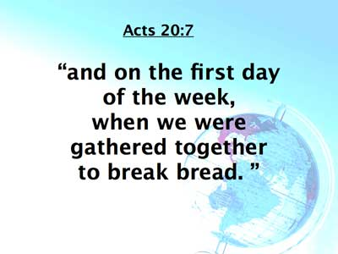

The terminology we use identifies frequency. If I say my birthday is March 1st, you do not ask, “Which March 1st?” March 1st pinpoints it as a yearly event since each year has a March 1st. If your boss were to tell you that you were to be paid on the 1st & 15th, you would not say “which month?”

Each week has a first day, and it was known that the disciples came together on that day to break bread.

However. . .there are other religious groups that observe something which they regard as the Lord’s Supper on a weekly basis, so at least, on this point, we are not the only ones.

5)

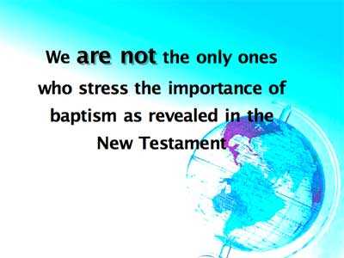

We stress that baptism should be immersion because that’s the definition of the original Greek word, and passages like:

[Matthew 3:16](https://biblia.com/bible/nasb95/Matt%203.16) –   
“and after being baptized, Jesus went up immediately from the water, and behold, the heavens were opened, and he saw the Spirit of God descending as a dove.”

[Acts 8:36-40](https://biblia.com/bible/nasb95/Acts%208.36-40) –   
this passage shows that baptism is to be by immersion.

[Romans 6:3-5](https://biblia.com/bible/nasb95/Rom%206.3-5) –  
this passage shows that baptism is to be by immersion.

[Col. 2:12](https://biblia.com/bible/nasb95/Col.%202.12) –   
“Having been buried with him in baptism, in which you were also raised up with him through faith in the working of God. . .”

However. . .we all know of some other religious groups that also teach that baptism is by immersion rather than sprinkling or pouring. We teach that baptism should be “for the forgiveness of sins (or the remission of sins) because of passages like:

[Acts 2:38](https://biblia.com/bible/nasb95/Acts%202.38) –   
“for the forgiveness of sins” (little Greek word used here “ace” (for), always prospective in application, this shows the purpose of Baptism). Means “in order to receive.”

[Mark 16:15](https://biblia.com/bible/nasb95/Mark%2016.15),[16](https://biblia.com/bible/nasb95/Mark%2016.16" \t "_blank) –   
“Go into all the world and preach the gospel to all creation. He who has believed and has been baptized shall be saved; but he who has disbelieved shall be condemned.”

[Acts 22:16](https://biblia.com/bible/nasb95/Acts%2022.16)   
“arise and be baptized and wash away your sins.”

[Gal. 3:26](https://biblia.com/bible/nasb95/Gal.%203.26),[27](https://biblia.com/bible/nasb95/Gal%203.27" \t "_blank) –   
“For you are all sons of God through faith in Christ Jesus. For all of you who were baptized into Christ have clothed yourselves with Christ.”

[I Pet. 3:21](https://biblia.com/bible/nasb95/1%20Pet.%203.21) –   
“and corresponding to that, baptism now saves you. . . “

Baptism is essential to salvation, as the Bible clearly demonstrates. . . but there are some other religious groups who teach and practice baptism as essential for salvation, so we are not “the only ones” who at least include it as a command from God that stands between the accountable sinner and salvation.

6)

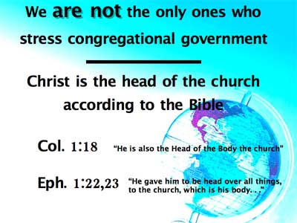

Christ, not Peter is the head of the church ([Col.1:18](https://biblia.com/bible/nasb95/Col.1.18) “He is also the Head of the Body the church”; [Eph. 1:22](https://biblia.com/bible/nasb95/Eph.%201.22),[23](https://biblia.com/bible/nasb95/Eph%201.23) “He gave him to be head over all things, to the church, which is his body. . .” [Phil. 1:1](https://biblia.com/bible/nasb95/Phil.%201.1),[2](https://biblia.com/bible/nasb95/Phil%201.2) – there Paul addresses the “deacons and elders.”)

However. . .there are many others who do not accept Peter as having been the head of the church. So we are not the only ones who follow the kind of government given to us by God in the Scriptures.

7)

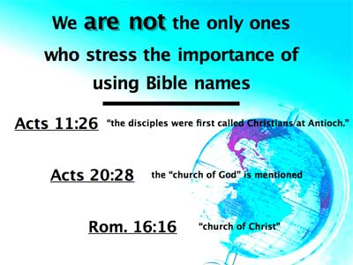

These are the Scriptural names:

[Acts 11:26](https://biblia.com/bible/nasb95/Acts%2011.26) – “the disciples were first called Christians at Antioch.”

[Acts 20:28](https://biblia.com/bible/nasb95/Acts%2020.28) – the “church of God” is mentioned

[Romans 16:16](https://biblia.com/bible/nasb95/Rom%2016.16) – “church of Christ”

However, we must admit that we are not the only ones who use these Biblical terms to identify the church.

8)

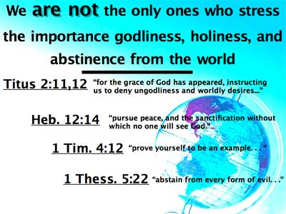

[Titus 2:11-12](https://biblia.com/bible/nasb95/Titus%202.11-12) –  
“for the grace of God has appeared, instructing us to deny . . . .

[Heb. 12:14](https://biblia.com/bible/nasb95/Heb.%2012.14) –   
“pursue peace, and the sanctification without which no one will see God.”

[I Tim. 4:12](https://biblia.com/bible/nasb95/1%20Tim.%204.12) –   
“prove yourself to be an example. . . “

[I Thess. 5:22](https://biblia.com/bible/nasb95/1%20Thess.%205.22) –   
“abstain from every form of evil. . .”

But we are not the only ones who teach this, and to be honest, we must admit that there may be some who show more dedication to the goal than many of our own!

9)

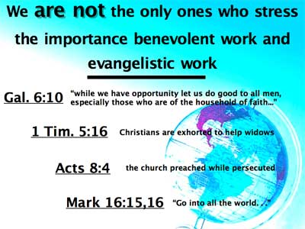

[Gal. 6:10](https://biblia.com/bible/nasb95/Gal.%206.10) –   
“so then, while we have opportunity, let us do good to all men, and especially to those who are of the household of Faith.”

[I Tim. 5:16](https://biblia.com/bible/nasb95/1%20Tim.%205.16) –   
exhorts us to help dependent widows

[Acts 8:4](https://biblia.com/bible/nasb95/Acts%208.4) –   
people preached even when they were prosecuted.

[Mark 16:15](https://biblia.com/bible/nasb95/Mark%2016.15),[16](https://biblia.com/bible/nasb95/Mark%2016.16" \t "_blank) –  
We are to go into all the world.

But. . . we must admit that there are other religious groups who are active in benevolent work, and there are many who may be supporting missionaries to preach their doctrine with a greater per capita level of giving than we have. We would not endorse the plan of salvation being taught by all other groups, but we do note that they believe in evangelism to teach what they do believe.

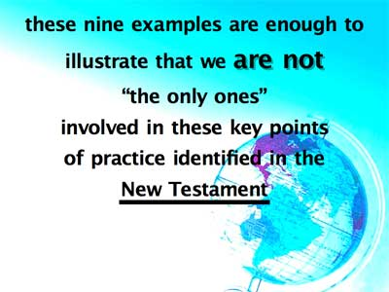

These nine examples are enough to illustrate the point: We are not “the only ones” involved in these key points of practice identified in the Scriptures. Is there any sense in which the church of Christ is different? Any sense in which it is truly “the only one?” Even though in each case we have studied there are some other religious groups who teach and practice the same basic things we have studied,

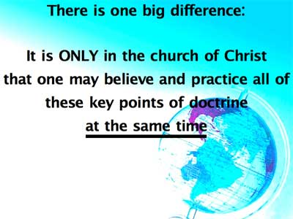

Let me illustrate. You may find that church “A” believes in baptism by immersion, but does not baptize for the remission of sins; church “B” may baptize for the remission of sins, but does not worship without adding instruments; church “C” may wear a Scriptural name, but does not take the Lord’s Supper each week, and so on.

Other churches may have a mixture of one or two of these cardinal matters of faith and practice, but omit the rest. You may find a dozen groups practicing tid-bits of truth, but who do you find besides the church of Christ making the plea that we get back to the Bible on all points of doctrine at the same time?

The plea of the restoration movement is that we be Christians, and Christians only, that we speak where the Bible speaks, and be silent where the Bible is silent, that we return completely to the New Testament for our authority in matters of faith and practice. That we speak the Truth, and nothing but the Truth ([John 17:17](https://biblia.com/bible/nasb95/John%2017.17)). We do not apologize for saying, “We must follow God and not Man.” Our plea to all is that we all unite under the unity of the Scriptures. When this is done, human traditions will fade into insignificance.